TaskTracker Instructions

Check PyCharm Version
Make sure you are using the latest stable release of PyCharm Community Edition or PyCharm Professional Edition (version 2024.3.5 as of March 23, 2025)
To check this:
- Click on the to open the Main Menu
  - On Mac, this will be in the top menu bar in PyCharm -> About PyCharm.
- Go to on Help -> About to get the below pop-up:
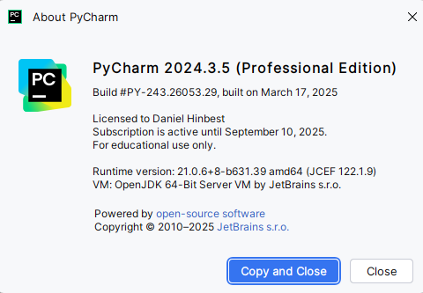
If it is not up-to-date, update your PyCharm installation by doing the following:
- Click on the to open the Main Menu
- Go to Help -> Check for Updates…
  - On Mac, this will be on the top menu bar
If you receive the following pop-up on the bottom of your screen, your PyCharm is already up-to-date:
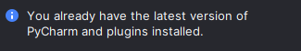

Installing TaskTracker
To install TaskTracker, go to the Google Drive link provided to you.
- Download the version of TaskTracker that matches your version of PyCharm:
  - tasktracker-1.1-community.zip if you are using PyCharm Community Edition
  - tasktracker-1.1-professional.zip if you are using PyCharm Professional Edition
- Save the zip file in a location where you can find it
Open your course project in PyCharm and install the plugin.
- In PyCharm, click on the icon and select Plugins… to open the Plugins menu
- Click on the icon in the Plugins menu and select Install Plugin from Disk…
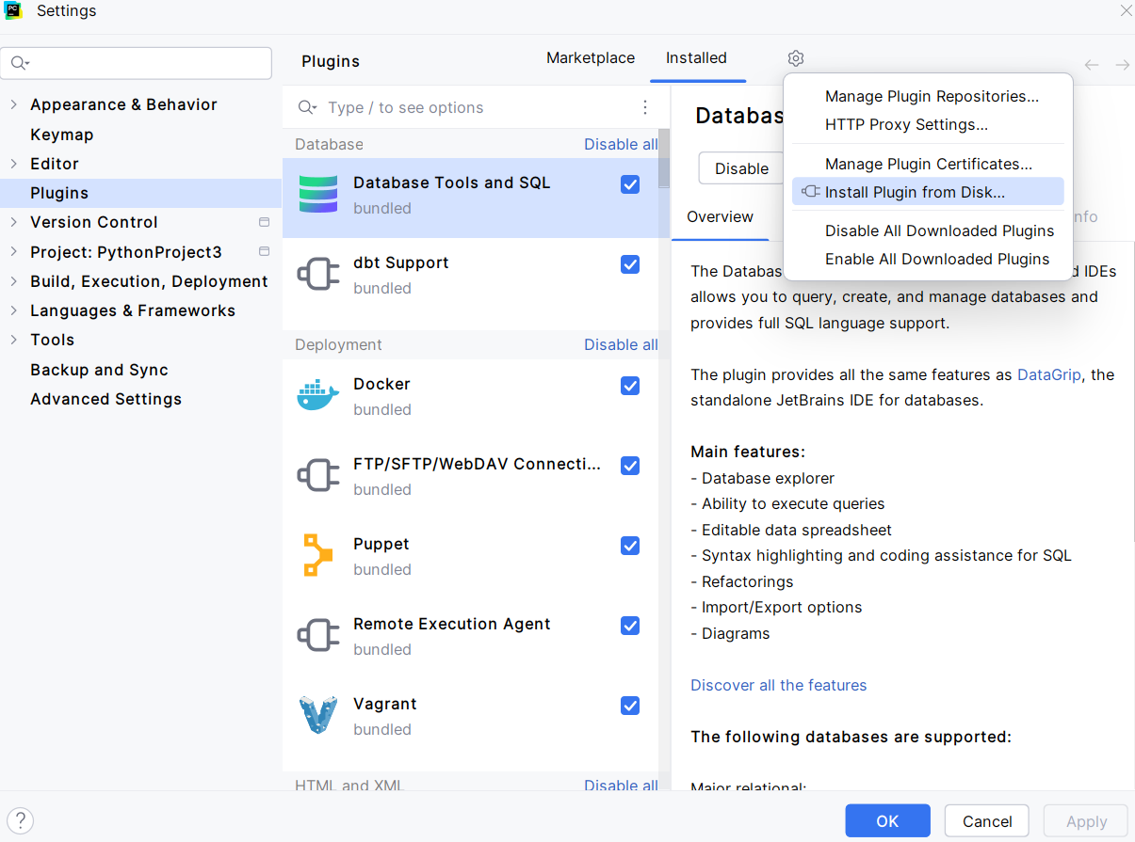

- Locate the tasktracker-1.1-community.zip or the tasktracker-1.1-professional.zip in the file explorer and click OK
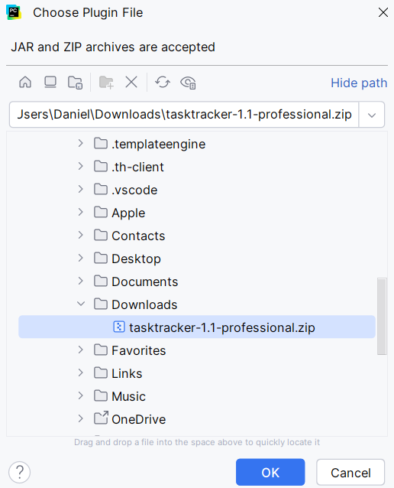
- Click OK in the plugins window to begin the installation. This will install TaskTracker and two of its dependencies – Activity Tracker and JavaFX Runtime for Plugins
- After a few moments, you should receive a prompt to restart PyCharm to complete the installation. Click Restart to proceed.
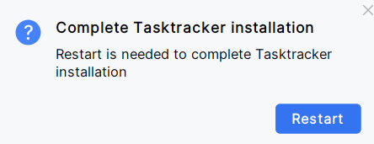
- After a moment, PyCharm should reload with TaskTracker installed. Please restart manually a second time to avoid a runtime issue. Once you have restarted a second time, TaskTracker should be functional

Using TaskTracker

Survey

Once TaskTracker is installed, it will be accessible on the right side of PyCharm and can be found with this icon and will look like the image below:
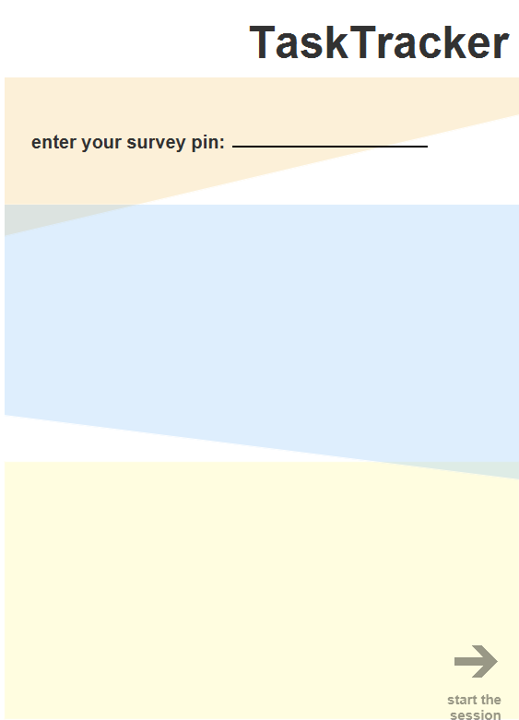
- In the survey pane, you will be asked to enter your PIN from the survey you completed earlier. Please enter it in the field above and click start the session when you are done.

Task Selection
The next screen you will see is Task Selection. There are three tasks to complete and they are focused on three forms of code coverage you have seen in the course – branch, path, and statement coverage.
To select a task:
- Click on the combo box under choose the task. You will be able to select one of the three options:
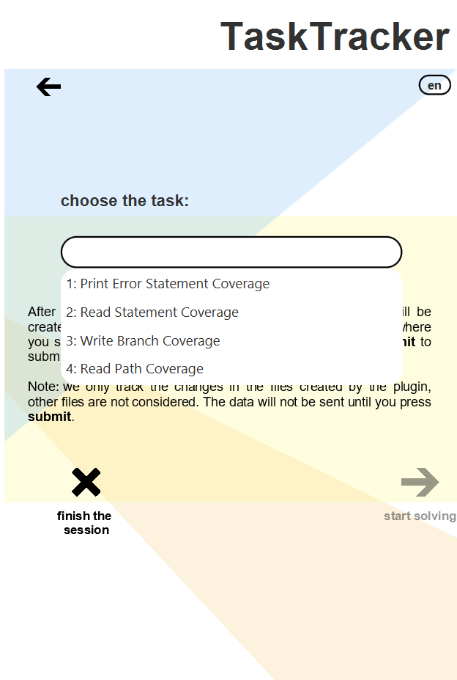
- After you select a task, click on start solving to work on it.

Solving a Task
- When you are solving a task, please prevent leaving comments such as your name and student number and write your code below the comment # Write your code here
- The files are stored in the tasktracker directory in the root of your project and each task can only be edited when the task is selected in TaskTracker.
- You can write and execute the code with no interruption
NOTE: When you are done the task, please make sure to back up your file in a separate location before submitting it. The files can be found in the tasktracker directory which is found in the root of the project.

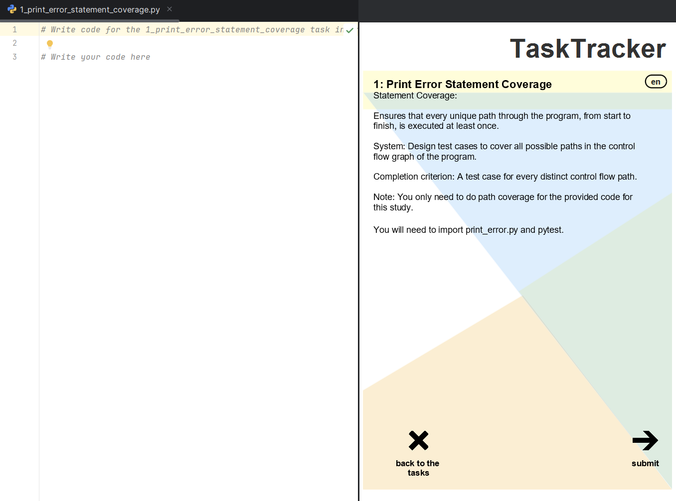
To submit the code, click submit in TaskTracker.
After it has been submitted, you will see the screen below. Click on back to the tasks to begin another task. This will return you to the task selection.

Uninstalling TaskTracker
Once the tasks have been completed, you can uninstall TaskTracker.
- Click on the icon at the top of PyCharm and select Plugins…
You will see three plugins to uninstall: Activity Tracker, JavaFX Runtime for Plugins, and task-tracker-plugin.
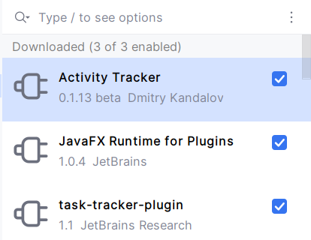
- On each of the plugins, click the and select Uninstall
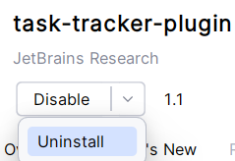
- Repeat this process for all three plugins
After all the plugins have been uninstalled, PyCharm will prompt you to restart.
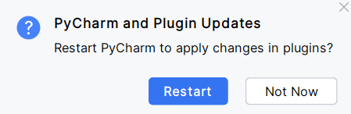
Click Restart to restart PyCharm. When it reloads, TaskTracker will be removed from PyCharm.

